Lab 6 Report 403

François-Eliott Rousseau 260670000

Mohamed Reda El Khili 260678513

Ismail Faruk 260663521

1. As we can see in the code below, we used all the coefficients that we got from the lab manual to generate the matrices A, B, C and D that are also defined below.

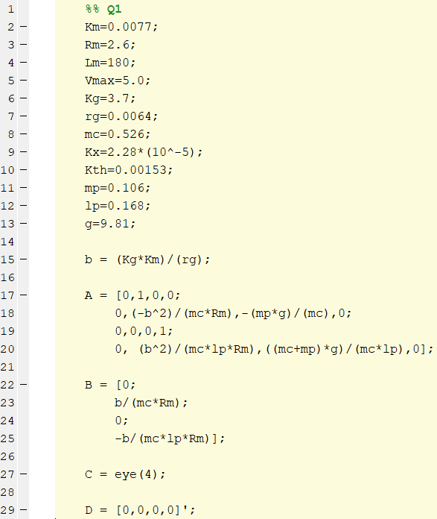

Figure 1: Code to define the state space system of the cart

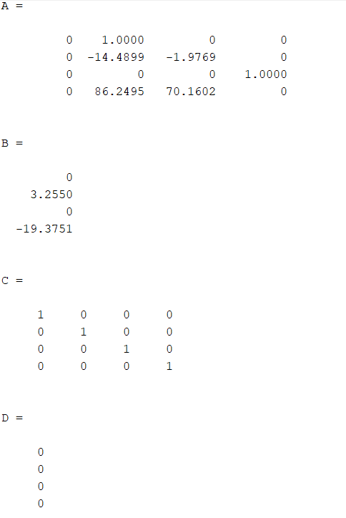

Figure 2: Matrices A, B, C and D

2)

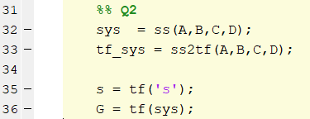

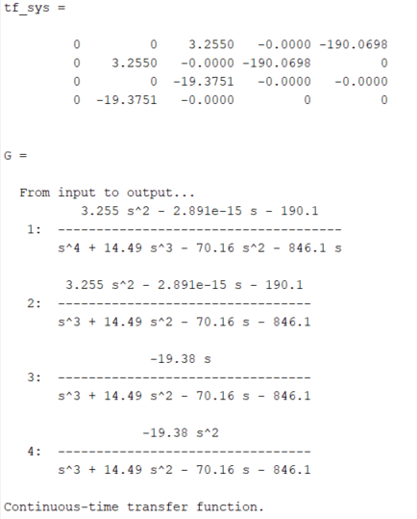

Figure 3: Definition of the transfer function on Matlab

3)



Figure 4: pzmap function for pole placement

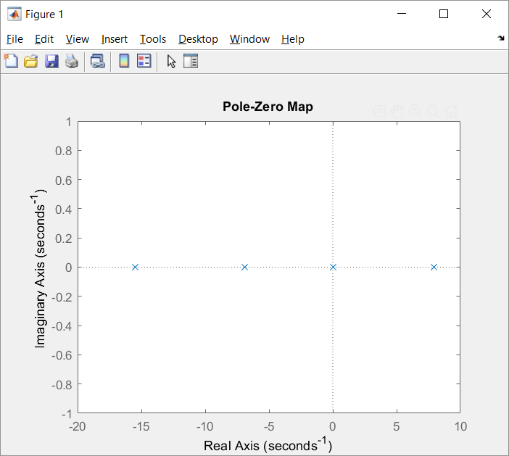

Figure 5: Pole placement

After placing the poles, we can conclude that the system is not stable because there is one pole greater than zero, which is thus located on the Open Right Hand Plane.

4)



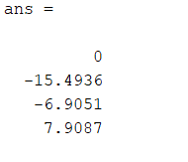

Figure 6: Eigenvalues of A

As we can see in the figure above, the eigenvalues of the matrix A are equal to the poles of the system.

5)

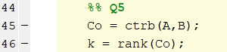

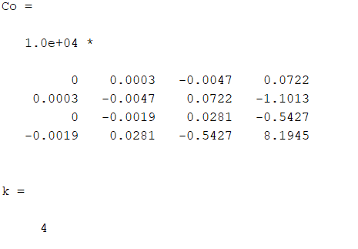

Figure 7: Controllability matrix

The system is controllable since the controllability matrix is full rank.

6) We do not need to check for Observability because matrix C is full rank, thus, system is observable.

7)

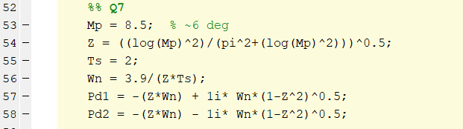

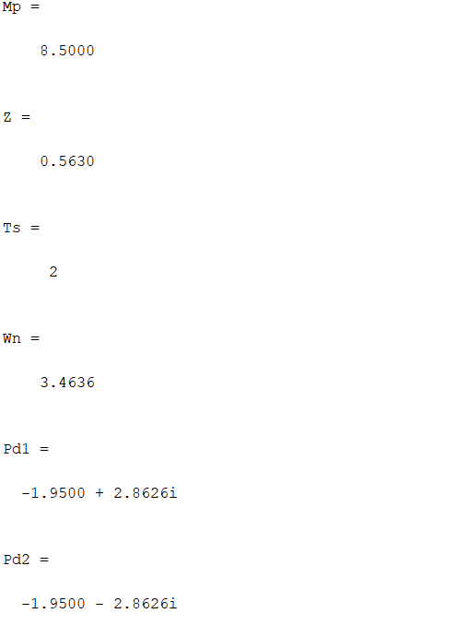



8)



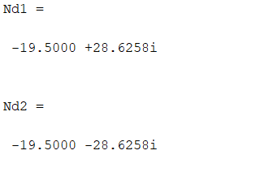

9-14)



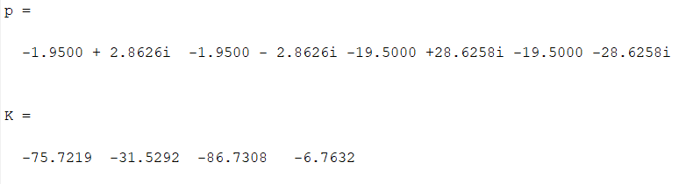

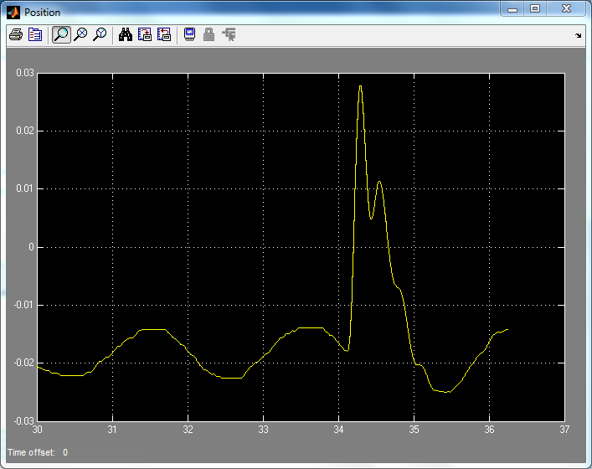

Figure: Position

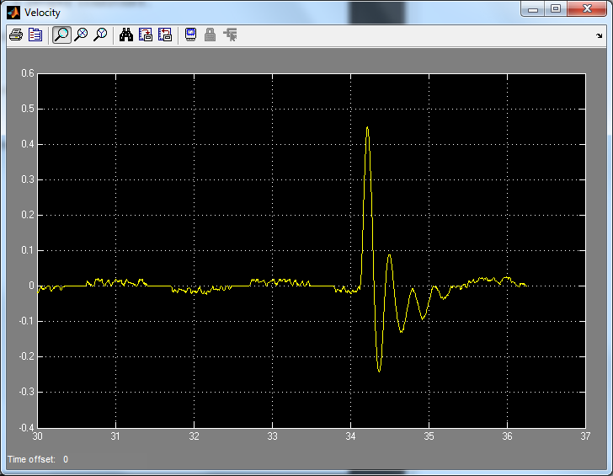

Figure: Velocity

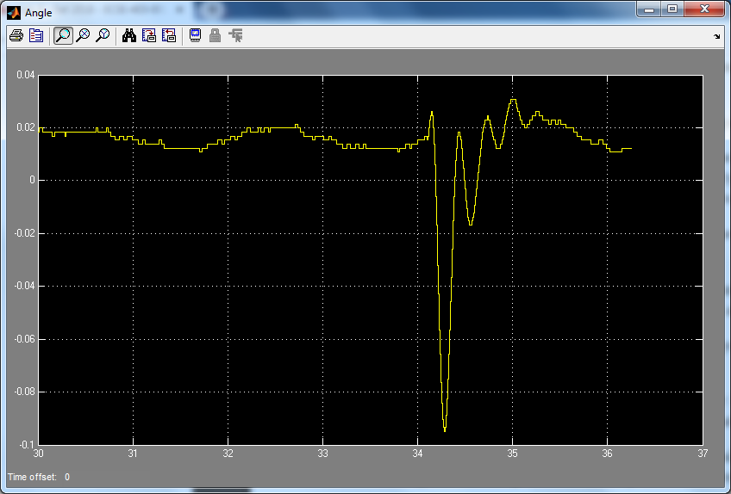

Figure: Angle

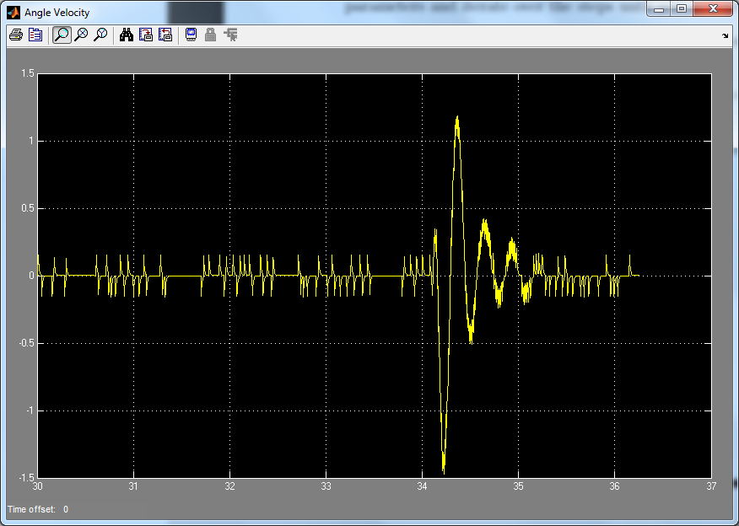

Figure: Angle Velocity

15) Increasing the value of K will decrease rise time and steady state error of the four quantities - position, velocity, angle, angle velocity - but increase the overshoot.

Appendix

%% Q1

Km=0.0077;

Rm=2.6;

Lm=180;

Vmax=5.0;

Kg=3.7;

rg=0.0064;

mc=0.526;

Kx=2.28*(10^-5);

Kth=0.00153;

mp=0.106;

lp=0.168;

g=9.81;

b = (Kg*Km)/(rg);

A = [0,1,0,0;

0,(-b^2)/(mc*Rm),-(mp*g)/(mc),0;

0,0,0,1;

0, (b^2)/(mc*lp*Rm),((mc+mp)*g)/(mc*lp),0];

B = [0;

b/(mc*Rm);

0;

-b/(mc*lp*Rm)];

C = eye(4);

D = [0,0,0,0]';

%% Q2

sys = ss(A,B,C,D);

tf_sys = ss2tf(A,B,C,D);

s = tf('s');

G = tf(sys);

%% Q3

pzmap(G);

%% Q4

eig(A);

%% Q5

Co = ctrb(A,B);

k = rank(Co);

%% Q7

Mp = 8.5; % ~6 deg

Z = ((log(Mp)^2)/(pi^2+(log(Mp)^2)))^0.5;

Ts = 2;

Wn = 3.9/(Z*Ts);

Pd1 = -(Z*Wn) + 1i* Wn*(1-Z^2)^0.5;

Pd2 = -(Z*Wn) - 1i* Wn*(1-Z^2)^0.5;

%% Q8

Nd1 = 10*Pd1;

Nd2 = 10*Pd2;

%% Q9 PP for Con

p = [Pd1, Pd2, Nd1, Nd2];

K = place(A,B,p);